**Ambient lighting**

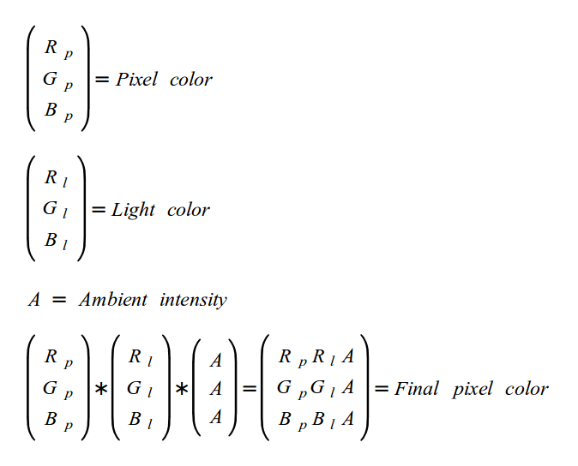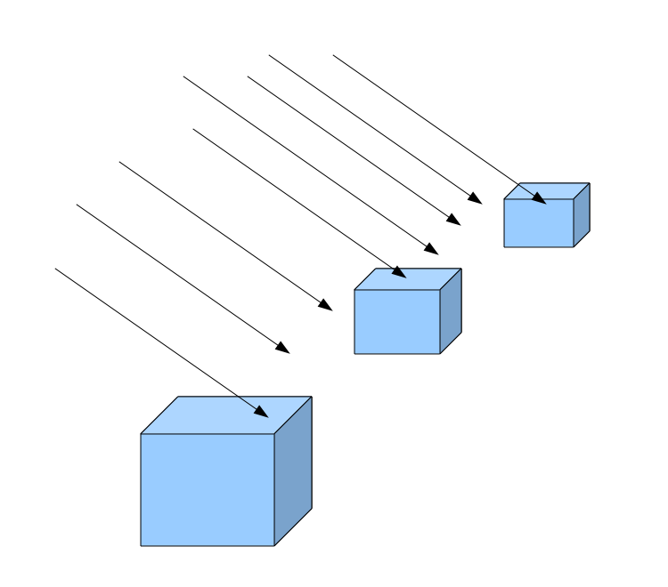 the ambient light is modeled as light that has no origin, no direction and has an equal affect on all objects in the scene

**Ambient Lighting**

http://ogldev.atspace.co.uk/www/tutorial17/tutorial17.html

**Specular Lighting**

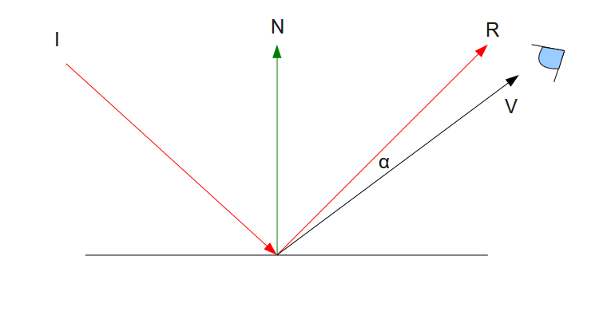

* 'I' is the incident light that hits the surface (and generates the diffuse light).
* 'N' is the surface normal.
* 'R' is the ray of light which is reflected back from the surface. It is symmetric across the normal from 'I' but its general direction is reversed (it points "up" and not "down").
* 'V' is the vector from the point on the surface where the light hits to the 'eye' (which represents the viewer).
* 'α' is the angle which is created by the vectors 'R' and 'V'.

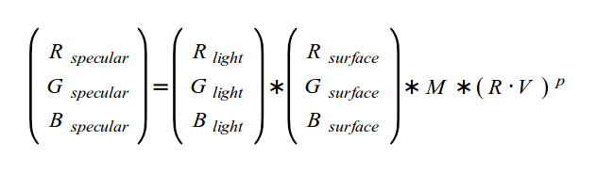

**M: the specular intensity**

**P: specular power, shiniess factor. Sharpen the edges of the area where the specular light is present**

1. The end result of specular lighting is that objects will look brighter from certain angles and this brightness will diminish as you move away.

2. Specular lighting is object dependent. The perfect real world example of specular lighting is metallic objects. These kinds of objects can sometimes be so bright that instead of seeing the object in its natural color you see a patch of shining white light which is reflected directly back at you. However, this type of quality which is very natural for metals is absent in many other materials (e.g. wood). Many objects simply don't shine, regardless of the where the light is coming from and where the viewer is standing. The conclusion is that the specular factor depends more on the object, rather than the light itself.

**Per-Fragment lighting**

**'M'** here is the specular intensity of the material. Material which does not have any specular property (e.g. wood) would have a specular intensity of zero which make it zero

Shinier stuff such as metal can have increasingly higher levels of specular intensity.

P is the "specular power' or the 'shininess factor'

**The three different kinds of light objects are**

**http://docs.worldviz.com/vizard/Light_basics.htm**

**1. Directional**

**2. Point**

**3. Spot**

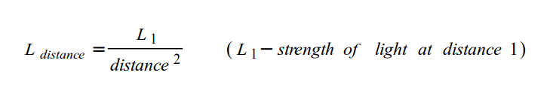**Point Light**

Fading effect of point light is usually called 'attenuation'

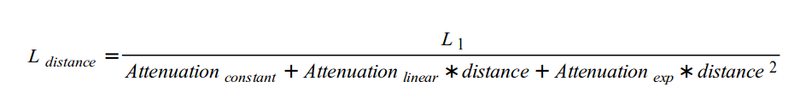

**Spot Light**

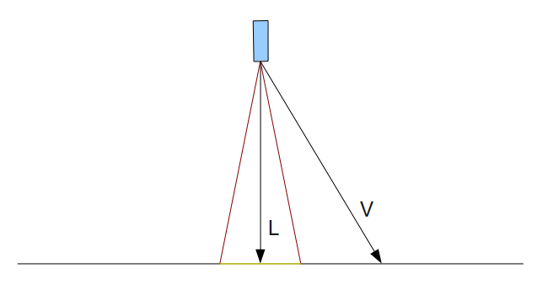

**L: light direction**

**V: light origin to the pixel**

if pixel in the cone, we want it to receive light

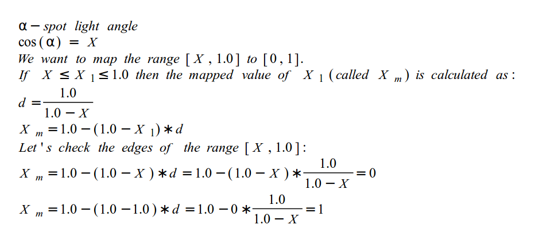imagine the cutoff angle is 20 degrees. Cosine(20) is 0.939, but the range [0.939, 1.0] is too small to serve as a factor. so we want to map the range [x, 1.0] to [0, 1]

